Power of Rural Social Media Posts

#PowerofRural: Rural Health Day is not just a day, it's a movement. On Rural Health Day we honor the selfless, community-minded spirit that prevails in rural America, and the everyday heroes that make rural life better every day. Register now for Telling the Rural Star Stories, a live webinar on November 18th at 11am PST with moving stories and tributes to 50 Community Starts from all 50 states! https://www.powerofrural.org/telling-the-rural-star-stories/
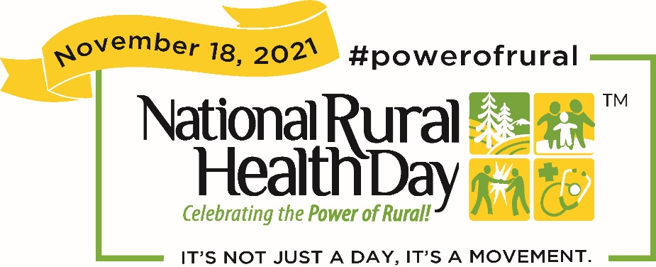

Recovery is a long road, but the rural landscape makes it a beautiful one. In rural communities, we know our neighbors and will have each other's backs when we know what to look for and how to help. #PowerofRural
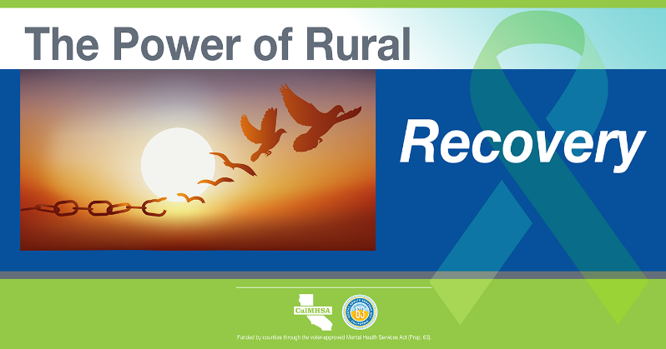

Rural communities are full of extraordinary people working together every day to make life better for their neighbors. #PowerofRural

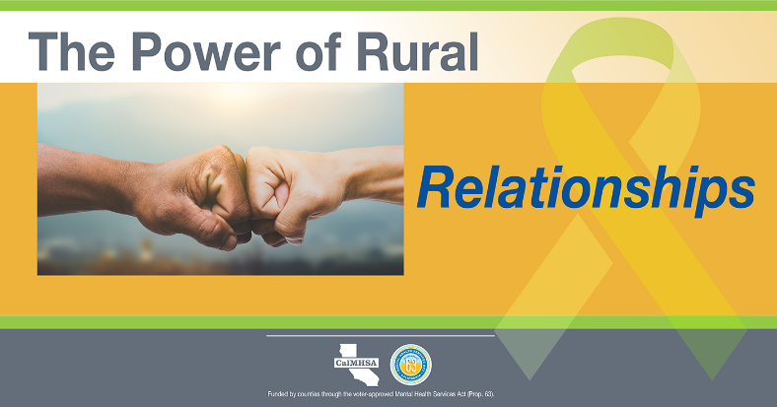

Rural communities know how to solve tough problems, endure hardship, and come out stronger together. #PowerofRural

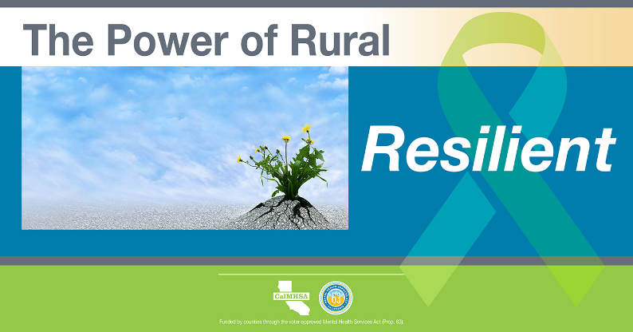

Rural life has its challenges, but there is little that can't be accomplished when communities come together to tackle any problem. #PowerofRural
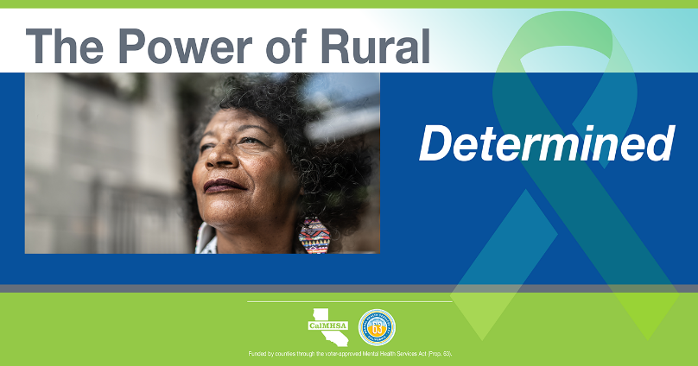
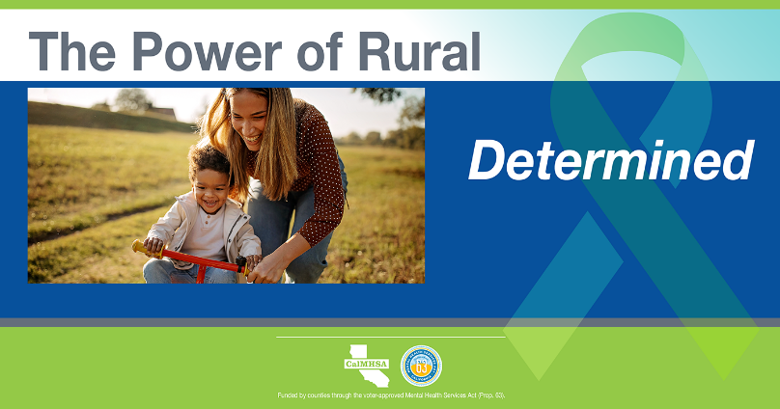
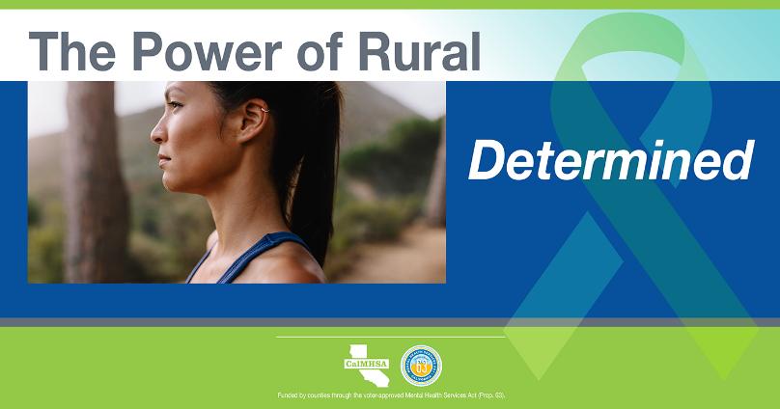
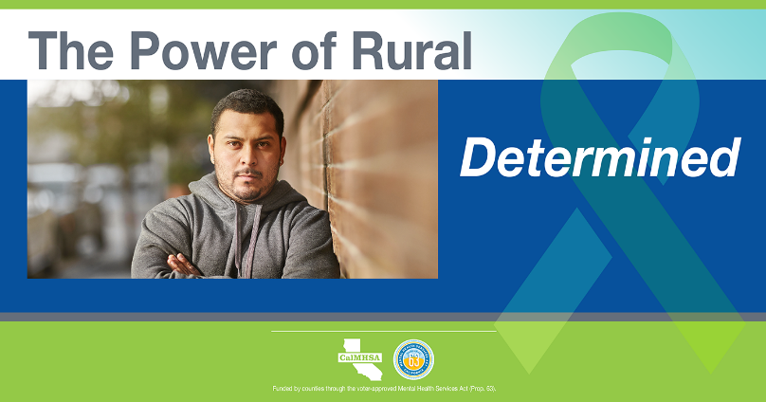

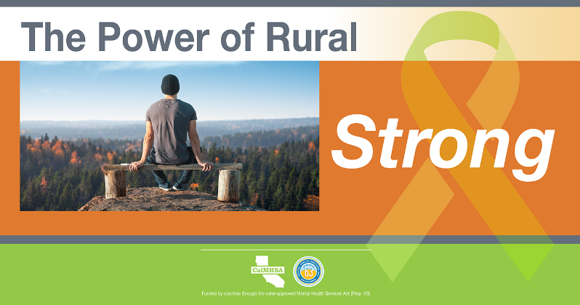
We are independent and self-reliant, and in tough times we have the strength to ask for help. #PowerofRural

In rural communities we come together to take care of our own. We wear many hats, and one of them is being there for those going through a tough time. #PowerofRural

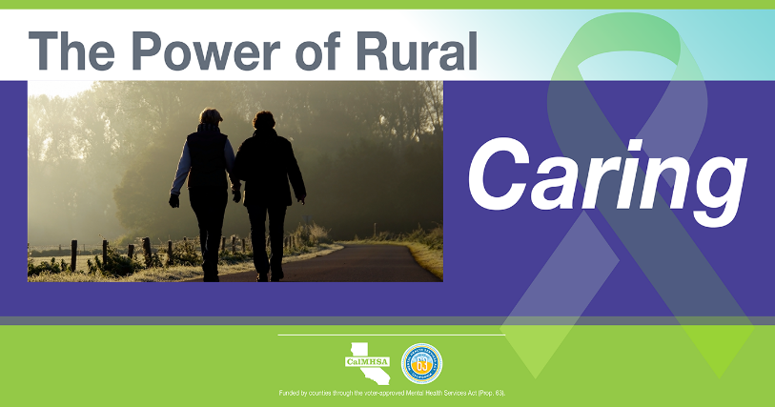

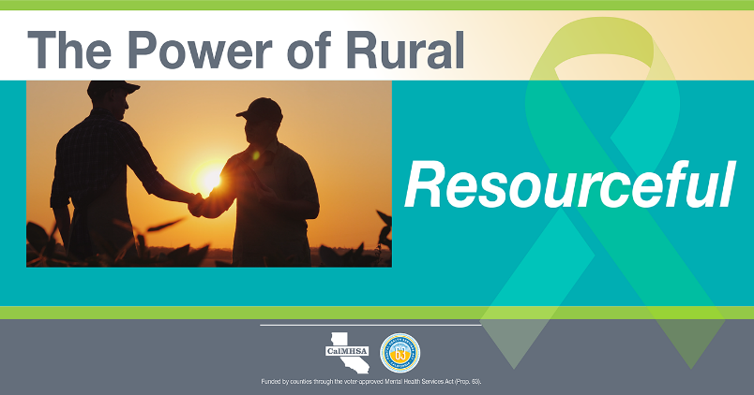
Rural communities know how to do more with less. We find creative ways to make things happen on our own. But when it comes to our mental health, we don’t have to. #PowerofRural

