Talking Points and Data Briefing
Suicide Prevention and Children: Building Resilience Through Social Emotional Learning

Take-Home Points:
- Suicidal behavior (ideation, attempts, and deaths) among younger children (age 5-12) is relatively infrequent but increases among adolescence and youth.
- Data on suicide among young children is difficult to interpret because the numbers are low and there are many different data sources to compare. Review local data and collaborate with the Child Death Review Team to accurately understand the problem in your community.
- Risk factors for suicidal behavior in younger children include behavioral problems, exposure to trauma, conflict with families or peers; these risk factors are shared with other negative outcomes including child abuse and neglect, and family and community violence.
- Suicide prevention for younger children is best focused on promoting protective factors and building resiliency and reducing stigma around mental health.
- Social and Emotional Learning is a powerful tool to help younger children cope with and manage their emotions and stressful situations.
- School-based and community settings can integrate Social and Emotional Learning programs into their curriculums and practices.

Suicidal Behavior in Younger Children

Suicidal behavior (ideation, attempts, and deaths) among younger children is relatively infrequent. Data on suicidal behavior among younger children is difficult to interpret because the numbers are low, and studies typically analyze many years to decades of data from multiple sources, which can make it challenging to compare results and identify clear trends. The data presented in this briefing focuses on younger children under age 13.

The leading causes of death among younger children are preventable unintentional injuries and violence (CDC). While overall childhood deaths from unintentional injury have decreased substantially as injury prevention efforts have taken hold, between 2007-2015 the rates of suicide and nonfatal self-harm among adolescents (10-14 years) increased by 130%. The most common means of suicide were suffocation, firearms, and poisoning. The leading causes of nonfatal self-harm were poisoning and cutting/piercing.

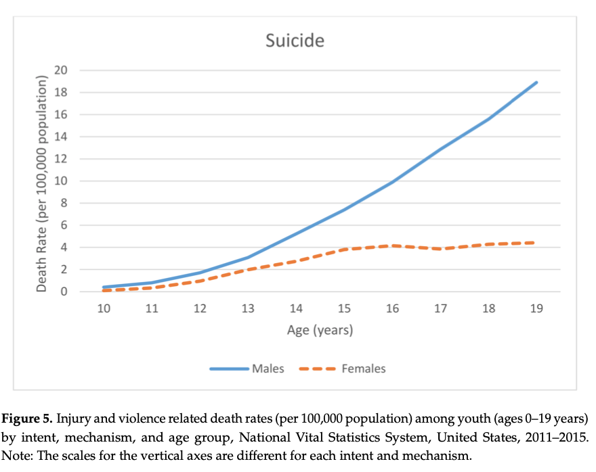

Whereas in general, suicide deaths and attempts are more likely to involve males, this gap is narrower among younger children (Ruch et. al, 2019). Some studies have reported that the rate of suicide among adolescent females (10-14 years) has been rising more rapidly than among adolescent males, and young females are more often using highly lethal means (particularly hanging/suffocation) (Ruch et. al, 2019).

Analysis of mortality data from the Centers for Disease Control and Prevention and morbidity data from the National Electronic Injury Surveillance System found that largely rural states had the highest youth and adolescent suicide rates (Ballesteros, et. al. 2018). The increase in suicide rates over the time period analyzed was also greater in non-metro areas (39.3%) than metro areas 25.8%) (Ballesteros, et. al. 2018).

Overall rates of suicidal behavior are higher among white than black individuals across most age groups. However a recent JAMA Pediatrics study of Centers for Disease Control and Prevention WISQARS data reported that between 2001-2015, the suicide rate among young black children (aged 5-12 years) was approximately 2 times higher than among young white children (Bridge et. al. 2018). This trend was reversed among black youth (aged 13-17), who had a 42% lower incidence of suicide than white youth. While most of the suicides were among black male children, the trend was observed for both sexes (Bridge et. al. 2018). A second study that analyzed National Violent Death Reporting System data from 17 states between 2003-2012 found that compared with early adolescents (age 12-14 years) who died by suicide, children (age 5-11 years) who died by suicide were more commonly male, black, died by hanging/strangulation/suffocation, and died at home (Sheftall et. al., 2016).

Sources
- Michael F. Ballesteros, Dionne D. Williams, Karin A. Mack, Thomas R. Simon and David A. Sleet. 2018. The Epidemiology of Unintentional and Violence-Related Injury Morbidity and Mortality among Children and Adolescents in the United States. International Journal of Environmental Research and Public Health, 2018, 15, 616; doi:10.3390/ijerph15040616.
- Donna A. Ruch, PhD; Arielle H. Sheftall, PhD; Paige Schlagbaum, BS; Joseph Rausch, PhD; John V. Campo, MD; Jeffrey A. Bridge, PhD. Trends in Suicide Among US Youth Aged 10 to 19 Years, 1975 to 2016. JAMA Network Open. 2019;2(5):e193886.
- O Miron, K-H Yu, R Wilf-Miron, and I S Kohane. Suicide Rates Among Adolescents and Young Adults in the United States, 2000-2017. JAMA Research Letter, June 18, 2019 Volume 321, Number 23
- Bridge, J, LM Horowitz, CA Fontanella, AH Shftall, J Greenhouse, KJ Kelleher, & JV Campo. Age-Related Racial Disparity in Suicide Rates Among US Youths From 2001 Through 2015. JAMA Pediatrics, July 2018, Volume 172, Number 7.
- Arielle H. Sheftall, Lindsey Asti, Lisa M. Horowitz, Adrienne Felts, Cynthia A. Fontanella, John V. Campo and Jeffrey A. Bridge. Suicide in Elementary School-Aged Children and Early Adolescents, Pediatrics, Volume 138, number 4, October 2016: e2016043.

Risk and Protective Factors for Young Children

Risk factors for suicide among young children include mental health and behavioral problems, family conflict, and a history of abuse (Anderson et.al., 2016). Risk factors for younger children are somewhat different from those commonly observed among youth and young adults. Suicidal behavior in young children is more often associated with attention deficit hyperactivity disorder (as many as 60% of cases) than depression or dysthymia (33% of cases) and is more often associated with conflict with family and peers than relationship problems (Sheftall et. al., 2016). Many younger children disclosed their intent to at least one person before their death.

Other research has found an association between bulimia and eating disorders in younger children and suicidal behavior. One study focusing on a target group of female patients aged 10-18 found that suicidal behavior had occurred in 60% of cases, and a suicide attempt was made in 9% of cases (Koutek et. al., 2016).

Adverse Childhood Experiences (ACEs) are stressful or traumatic events that children under the age of 18 experience at home or in their community. They may include abuse, neglect, and various types of household dysfunction. The original ACE study (Figure 1) identified 10 ACEs; more recent research expanded the range of traumatic experience to include factors such as community violence, racism, economic hardship and food insecurity.

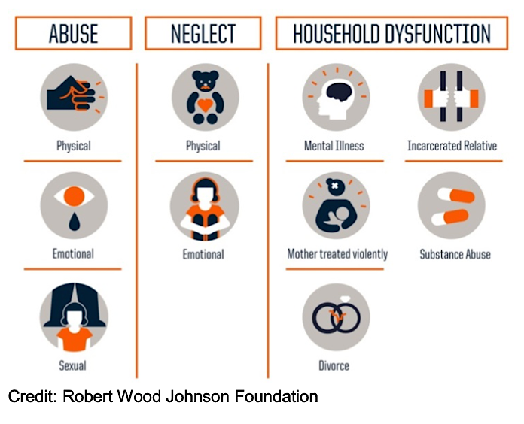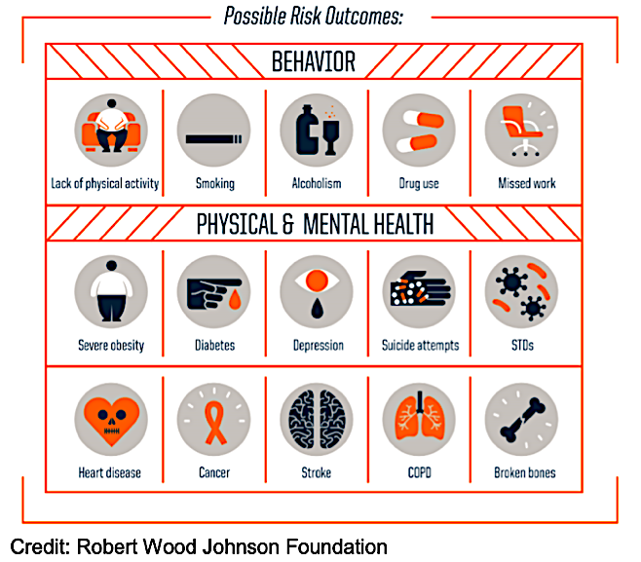

Exposure to ACEs without buffering influences can dysregulate a child's stress response, leading to "toxic stress." Toxic stress is associated with learning difficulties and health among children. (CDC, Adverse Childhood Experiences) Exposure to ACEs is a risk factor for a wide range of longer-term health and mental health problems, including depression and suicide attempts, that can extend into adulthood. Buffering influences are protective factors that build resiliency, such as a caring and supportive relationship with caregivers; problem solving and coping skills; strong connection with social, cultural and spiritual supports; and therapy.

In California, as in other states, ACEs are relatively common, but not evenly distributed in the population. Behavioral Risk Factor Surveillance System (BRFFS) data (2011-2013) found that more than half of Californians had experienced at least one ACE, and 25% had experienced three or more. Respondents with a higher number of ACEs were more likely to have less education and lower adult income. The racial/ethnic groups with the highest prevalence of ACEs were Aleutian, Eskimo and American Indian (35%), Non-Hispanic Black (20%), Hispanic (18%) and Non-Hispanic White (16%). The group with the lowest prevalence was Asian/Pacific Islander (7%).

Children who experience physical abuse or neglect early in their lives are at greater risk of perpetrating violence later, particularly boys (Wilkins et al, 2018). Protective factors that buffer the impact of ACEs and reduce the risk of behavioral health and health problems, suicide, and violence include caring, nonviolent and supportive relationships; social connections with groups such as schools or faith-based organizations; a sense of safety at home, in schools, and in neighborhoods and communities; and access to age-appropriate mental health services and supports when behavioral problems emerge. Similarly, to risk factors, the greater the number of protective factors present, the stronger the mitigating effect on risk.

Nonsuicidal self-injury includes behaviors that are self-injurious but not accompanied by suicidal intent. According to Youth Risk Behavior Surveillance System data, over 17% of adolescents reported having engaged in at least one nonsuicidal self-injury in the past year; about 1 in 10 were male and 1 in 4 were female (Westers and Culyba, 2018). Nonsuicidal self-is a strong risk factor for future suicide attempts (Westers and Culyba, 2018; Kara et. al, 2015). In addition, nonsuicidal self-injury and suicidal behavior often share risk factors such as adverse childhood experiences, mental health conditions, and problems with emotional regulation, coping skills and problem solving (Horner 2016).

Sources
- Anderson, AR, GM Keyes, and DA Jobes. 2016. Understanding and treating suicidal risk in young children. American Psychological Association, Practice Innovations, Vol 1, No. 1, 3-19.
- AH Sheftall, L Asti, LM Horowitz, A Felts, C. Fontanella, J. Campo and JA Bridge. Suicide in Elementary School-Aged Children and Early Adolescents, Pediatrics, Volume 138, number 4, October 2016: e2016043.
- Koutek J, K Kocourkova, & I Dudova. Suicidal behavior and self-harm in girls with eating disorders. Neuropsychiatric Disease and Treatment, 2016: 12 787-793.
- Essentials for Childhood Initiative, July 2016, Fact Sheet
- Adverse Childhood Experiences, Robert Wood Johnson Foundation
- Brockie TN, Elm JHL, Walls ML. Examining protective and buffering associations between sociocultural factors and adverse childhood experiences among American Indian adults with type 2 diabetes: a quantitative, community-based participatory research approach. BMJ Open 2018; 8: e022265. doi:10.1136/ bmjopen-2018-022265.
- Wilkins, N, L Myers, T Kuehl, Bauman, and M Hertz. Connecting the Dots: State Health Department Approaches to Addressing Shared Risk and Protective Factors Across Multiple Forms of Violence. J Public Health Manag Pract. 2018 ; 24(Suppl 1 INJURY AND VIOLENCE PREVENTION): S32–S41. doi:10.1097/PHH.0000000000000669.
- NJ Westers and AJ Culyba. Nonsuicidal Self-Injury: A Small Step Toward Addressing a Neglected Public Health Problem Among Adolescents. Am J Public Health, 2018 August; 108(8): 981-983. doi:10.2105/AJPH.2018.304550.
- Kara K, S Ozsoy, H Teke, MA Congologlu, T Turker, T Renklidag, M Karapirli. Nonsuicidal self-injurious behavior in forensic child and adolescent populations.
- Horner G. Nonsuicidal self-injury. Journal of Pediatric Health Care, Vol. 30, Issue 3, P261-267, May 01, 2016. DOI: https://doi.org/10.1016/j.pedhc.2015.06.012.
Suicide Prevention Strategies for Younger Children

While suicide is uncommon among young children, the frequency of suicide increases through adolescence and into young adulthood. Suicide prevention efforts that start with younger children may help reduce this risk. Strategies for younger children must take developmental considerations into account and recognize that they can vary widely with age and individual children. Regardless of how well an individual child understands the concepts of death and suicide, experts recommend taking seriously any disclosure of suicidal intent; the fact that they are thinking about it signals severe distress and that the child needs help and support (Anderson et.al., 2016).

Most suicide prevention efforts that focus on young children center around enhancing protective factors, building resiliency, identifying and treating early signs of mental health problems, and fostering supportive environments in homes and at school (Children's Safety Network, 2012).

Existing violence prevention (including intimate partner violence) and childhood maltreatment prevention initiatives often incorporate multi-level, multi-sector collaborative approaches that address many of the shared risk and protective factors that are the focus of suicide prevention (Wilkins et. al, 2018). Veto Violence is a CDC initiative that provides tools and resources for collaborative community violence prevention, including Connecting the Dots, an online training program that explores how multiple forms of violence, including child abuse and neglect, intimate partner violence, sexual violence, youth violence, and suicide share common risk and protective factors that can form the basis for collaborative prevention. Collaborative prevention can help prevent multiple negative outcomes at the same time, increasing the reach and scale of prevention efforts, especially in families and communities that are impacted by multiple challenges. Finally, addressing shared risk and protective factors that impact children can have long lasting effects.

The California Essentials for Childhood Initiative outlined 10 goals uniting the efforts of multiple agencies and stakeholders to ensure that all California children, youth, and their families have safe, stable, nurturing relationships and environments. While the goals were developed to prevent or reduce child abuse, maltreatment, and neglect, they are focused on building protective factors that create a foundation of resiliency that can reduce the risk of suicidal behavior among young children and be protective later in life. Examples of shared risk and protective factors for suicide and child maltreatment include:

Risk Factors
Substance misuse
Mental health issues
Social Isolation
Lack of access to behavioral health services
Protective Factors
Family and community support (connectedness)
Access to behavioral health services

Goals of the California Essentials for Childhood Initiative
- Build upon families' assets to strengthen their knowledge and skills to provide safe, stable and nurturing relationships and environments for their children.
- Achieve the highest level of well-being for families and children, with special attention to those who have experienced socioeconomic disadvantage and historical injustice, including vulnerable communities and culturally, linguistically, and geographically isolated communities.
- Prevent child maltreatment and other childhood traumas and implement trauma informed policies and practices throughout public and private organizations and systems.
- Improve the quality of and expand the accessibility to programs and services supporting families and children.
- Enhance the integration of systems and networks that support families and children to improve communication, services, accountability and outcomes.
- Engage communities and strengthen their capacity to act and take leadership roles in creating safe and stable environments that support families and children.
- Build public support and commitment (or …"public commitment and political will…") for policies and programs that promote safe, stable and nurturing relationships and environments for families and children.
- Embed and incorporate families and children as priorities in public policies.
- Increase the number and scope of private sector policies and practices that support families and children.
- Improve and enhance data systems that use common measurements to increase accountability for shared indicators and outcomes for families and children.

A meta-analysis of nearly 100 studies of youth suicide prevention programs suggested that school-based programs that combine education with screening have the potential to be effective, and that the most evidence for reducing rates of suicide and/or self-harm are found in approaches that combine many elements, from universal education programs, gatekeeper training, screening and treatment responses where appropriate (Pelkonen & Marttunen, 2003).

Family Intervention for Suicide Prevention is an evidence-based practice for youth aged 10-18 that is intended to decrease the risk of repeated suicidal behavior after a suicide attempt or ideation through cognitive behavioral therapy that involves the child as well as their family.

Sources:
- Children's Safety Network, Youth Suicide Prevention Community of Practice Webesinar (2012). The Relationships between Child Maltreatment and Suicide & A Comprehensive Approach to Suicide Prevention.
- Wilkins, N, L Myers, T Kuehl, Bauman, and M Hertz. Connecting the Dots: State Health Department Approaches to Addressing Shared Risk and Protective Factors Across Multiple Forms of Violence. J Public Health Manag Pract. 2018 ; 24(Suppl 1 INJURY AND VIOLENCE PREVENTION): S32–S41. doi:10.1097/PHH.0000000000000669.
- Pelkonen, M & M Marttunen. Child and Adolescent Suicide: Epidemiology, Risk Factors, and Approaches to Prevention. Pediatric Drugs, 5, 243-265(2003), published 30 August 2012.
- Anderson, AR, GM Keyes, and DA Jobes. 2016. Understanding and treating suicidal risk in young children. American Psychological Association, Practice Innovations, Vol 1, No. 1, 3-19.
- Center for Disease Control and Prevention. Veto Violence Initiative web site.

Social Emotional Learning

Social and Emotional Learning (SEL) is the process, through which children and adults acquire and effectively apply the knowledge, attitudes and skills necessary to understand and manage emotions, set and achieve positive goals, feel and show empathy for others, establish and maintain positive relationships, and make responsible decisions. SEL utilizes an outside-in approach, with a focus on teaching skills; for example, a teacher introduces a skill such as recognizing an emotion, the students practice it for a set amount of time, and then the teacher moves on to the next skill.

The skills and strategies that children gain through SEL have been shown to increase protective factors and reduce risk factors associated with suicide. A growing body of research supports the use of evidence-based SEL programming in the school setting. Students receiving quality SEL instruction demonstrated improvement in academic performance, attitudes and behaviors, and reductions in negative behaviors and emotional distress. Furthermore, research has found that SEL programming in youth can have a positive impact up to 18 years later on academics, conduct problems, emotional distress and drug use.

The Good Behavior Game is an example of a social emotional learning approach that uses a game format to promote healthy socialization. Research has found that it reduces aggressive, disruptive classroom behavior, which is a shared risk factor for later problem behaviors.

Social Emotional Learning Resources
- Collaborative for Academic, Social and Emotional Learning (CASEL)
- CARE for Teachers Program
- Center on the Social and Emotional Foundations for Early Learning
- Navigating Social and Emotional Learning from the Inside Out— Looking Inside and Across 25 Leading SEL Programs: A Practical Resource for Schools and OST Providers) Elementary School Focus
- Social and Emotional Learning Resource Finder
- California Social and Emotional Learning Community of Practice, is a partnership with Sacramento, Orange, and Butte Counties to build capacity within County Offices of Education. For more information contact, Dr. Lucy Vezzuto at Ivezzuto@ocde.us or Brent Malicote at bmailicote@scoe.net.
- California Department of Education: Social and Emotional Learning

Social Connectedness
Connectedness is the degree to which a person or group is socially close, interrelated, or shares resources with other persons or groups. The definition encompasses connections between individuals, their families, community organizations and social institutions. A significant amount of research establishes connectedness as a protective factor amongst adolescents.
Adolescents and youth who feel close to their parents are less likely to engage in violence and have lower risk for internalizing disorders, a type of emotional and behavioral disorder, and are less likely to attempt suicide. Adolescents and youth who feel valued in their school communities by peers and adults have been found to have improved academic outcomes and a decrease in risky behaviors. There is also a strong association between positive social, academic, and health-related behaviors amongst youth who were involved in high-quality youth-mentor relationships. Other measures of connectedness such as perception of being able to count on their community for support and assistance, and of being cared for by adults in their community, were found to be protective factors against suicidal ideation and attempts among a national sample of Native American youth.

Sources of Strength is an evidence-based program that seeks to prevent suicide by increasing help seeking behaviors and promoting connections between peers and caring adults. Sources of Strength is one of the first suicide prevention programs to involve peer leaders in an effort to enhance protective factors associated with reducing suicide at the school population level. The organization has a variety of free activities that can be used by educators as well as parents:
- Educator and Online Classroom Resources
- Emotion Check-in List
- Reflect + Connect: Seven Days of Journal Prompts

Sources
- Farrell AD, Mays S, Bettencourt A, Erwin EH, Vulin-Reynolds M, & Allison KW (2010). Environmental influences on fighting versus nonviolent behavior in peer situations: A qualitative study with urban African American adolescents. American Journal of Community Psychology, 46(1–2), 19–35.
- Day RD, & Padilla-Walker LM (2009). Mother and father connectedness and involvement during early adolescence. Journal of Family Psychology, 23(6), 900–904.
- Borowsky IW, Ireland M, & Resnick MD (2001). Adolescent suicide attempts: Risks and protectors. Pediatrics, 107(3), 485–493.
- Booker KC (2006). School belonging and the African American adolescent: What do we know and where should we go? The High School Journal, 89(4), 1–7.
- Dornbusch SM, Erickson KG, Laird J, & Wong CA (2001). The relation of family and school attachment to adolescent deviance in diverse groups and communities. Journal of Adolescent Research, 16(4), 396–422.
- Sieving, R. E., McRee, A. L., McMorris, B. J., Shlafer, R. J., Gower, A. L., Kapa, H. M., … Resnick, M. D. (2017). Youth-Adult Connectedness:: A Key Protective Factor for Adolescent Health. American journal of preventive medicine, 52(3 Suppl 3), S275–S278. doi:10.1016/j.amepre.2016.07.037
- Borowsky IW, Resnick MD, Ireland M, & Blum RW (1999). Suicide attempts among American Indian and Alaska native youth: Risk and protective factors. Archives of Pediatrics & Adolescent Medicine, 153(6), 573–580.

Key Partners for comprehensive suicide prevention among young children include parents, educators and other organizations and providers in your community reaching children and youth. Reach out to local organizations in your community to build upon existing efforts.
- Parents and caregivers
  - Yolo County Children's Alliance, Parent Education Guides
  - Healthychildren.org, Responding to Children's Emotional Needs During Times of Crisis
- Schools
  - California Department of Education - Youth Suicide Prevention
  - Directing Change Program and Film Contest - For Schools
  - Suicide Prevention Resource Center
  - HEARD Alliance K-12 Toolkit for Mental Health Promotion and Suicide Prevention is a roadmap for comprehensive youth suicide prevention strategies that link together families, schools, providers and others.

- Violence prevention programs and initiatives
  - California Essentials for Childhood Initiative
  - Connecting the Dots Online Training
  - California Office of Child Abuse Prevention
  - California Partnership to End Domestic Violence
- Community-based children and family service organizations.
  - Visit the California Alliance web site to find member agencies in your community
- Pediatricians and family practice physicians
  - American Academy of Pediatrics - Suicide Prevention
- Child Death Review Teams are county interagency groups that meet at least once per year to review deaths of children under age 18. The ultimate purpose of Child Death Review Teams is prevention. To find you county's team reach out to your county Health ahd HumTeams may analyze data to identify trends and prevention. Contact strategies and in a county and develop recommendations for preventing and responding to future child deaths

Each Mind Matters Initiatives

Walk In Our Shoes is a mental health and stigma reduction initiative that focuses on children ages 9-13; Ponte en Mis Zapatos is the Spanish language campaign. The campaign web sites include authentic and age-appropriate stories that encourage children to talk about mental health, practice compassion and confide in a trusted adult. For Grown Ups/Para Adultos provides educational resources for parents and classroom activity guides and lesson plans for teachers. The Directing Change Program's Superheroes and Purpose Lesson Plan is designed for middle school students preparing submissions to the film contest, but can be used in other settings.

