Tuesday September 10: Direct Message

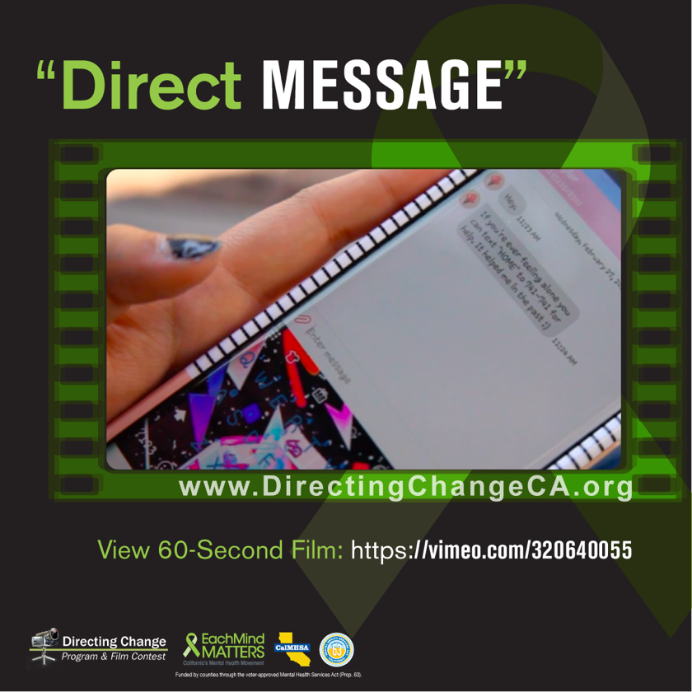

Today is World Suicide Prevention Day. The theme of World Suicide Prevention Day is “working together to prevent suicide”, and we believe every person has a role they can play in helping to prevent suicide in their community. One event that is being observed across the globe is the lighting of a candle at 8 pm local time: place the lighted candle near a window to show your support, remember a lost loved one, and for the survivors of suicide. Learn more about this activity and send e-cards and postcards in observance of the day here: https://www.iasp.info/wspd2019/light-a-candle/

Join others in showing your support for World Suicide Prevention Day by sharing the featured Directing Change film below!

Highlighted Film: Direct Message

Created by Taylor Krutsch, Joshua Guerrero, and Alexis Paramo from Encore High School, Riverside County
- Film Link: https://vimeo.com/320640055
- A girl confides in her friend through text, asking him to not tell anyone. He debates between breaking her trust or keeping it. He tells a third party who gives the girl the resource "text "HOME" to 741-741" and we see her text this number to reach out for help.

- Share the Film: Breaking a friend’s trust is something no one wants to do, but if they are in crisis it can be necessary. This film shows a boy connecting his friend to a text line when she admits that she has been thinking about suicide https://vimeo.com/320640055 #SPWeek #SuicidePreventionWeek2019 #directingchange #bethe1to

Using technology to help prevent suicide. There are a lot of conversations nowadays about whether technology is a blessing or a curse. Despite its shortcomings, technology can be a great tool to facilitate help-seeking. People of all ages are increasingly turning online for resources, mobile apps, and text options when seeking help for themselves or friends in need. If someone in your life, regardless of age, wants some alternative ways to access help, the national suicide prevention hotline is available via text at 741-741 by texting the word “HOME”. Online chats are also available at https://suicidepreventionlifeline.org/chat/ and through the Trevor Project at https://www.thetrevorproject.org/get-help-now/.

To view and download free educational resources, activity ideas, and films, visit: www.directingchangeCA.org or access the Each Mind Matters Suicide Prevention Week Activation Kit at https://www.eachmindmatters.org/spw2019/

About Directing Change: The Directing Change Program & Film Contest is an evaluated youth engagement program. Directing Change engages students and young people throughout California to learn about the topics of suicide prevention and mental health by creating short films that are used to support awareness, education, and advocacy efforts on these topics. Youth apply knowledge about mental health and suicide prevention to create their own unique message about suicide prevention for their peers. Through the creative process of filmmaking young people are engaged via all methods of the learning spectrum: to see, experience, discuss, and apply. These students are recognized for their efforts at a red-carpet award ceremony and their films help impact social change at their schools and in their communities. Directing Change is part of Each Mind Matters: California's Mental Health Movement and statewide efforts to prevent suicide, reduce stigma and discrimination related to mental illness, and to promote the mental health and wellness of students. These initiatives are funded by counties through the Mental Health Services Act (Prop 63) and administered by the California Mental Health Services Authority (CalMHSA), an organization of county governments working to improve mental health outcomes for individuals, families, and communities.

