Monday September 9: Reaching Out
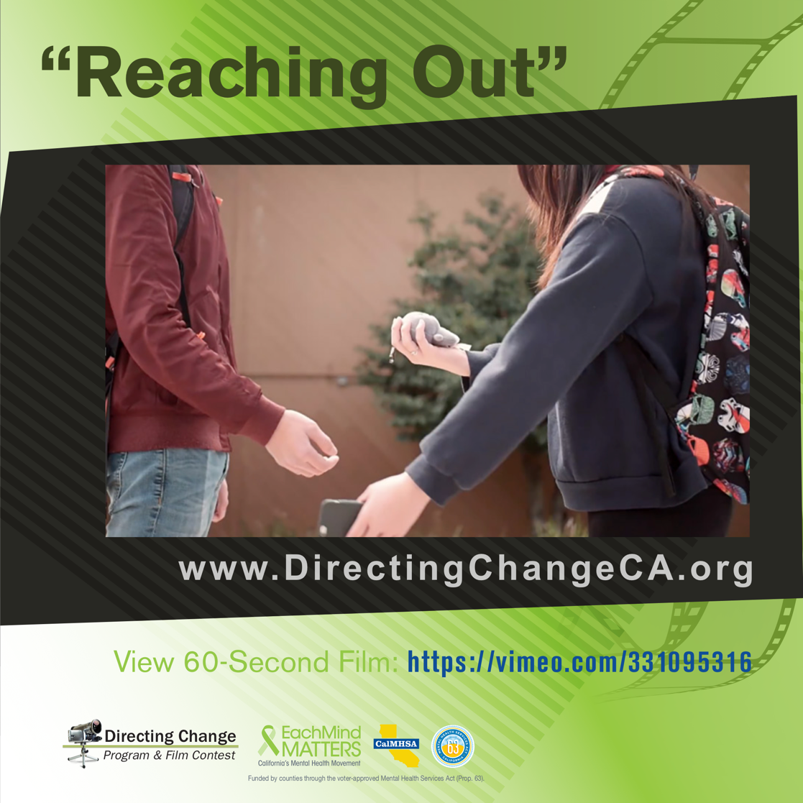

Yesterday marked the beginning of our nation’s annual Suicide Prevention Week. During this week individuals and organizations around the country join their voices together to broadcast the message that suicide can be prevented, as well as give as many people as possible the tools and resources to support themselves and those around them.

One activity that all community members, regardless of age or location, can participate in is Active Minds’ “Here For You” campaign: this positive social media campaign encourages people to share who has been there for them during difficult times, and to spread the message using the hashtag #hereforyou. A single conversation can be life-changing, and we want to hear about one that changed your life for the better. Watch the personal stories and share your own here: https://www.activeminds.org/about-mental-health/here-for-you/

To view and download free educational resources, activity ideas, and films, visit: www.directingchangeCA.org or access the Each Mind Matters Suicide Prevention Week Activation Kit at https://www.eachmindmatters.org/spw2019/

- Share today’s featured film Reaching Out via social media: A sudden change in behavior can be a warning sign that someone is considering suicide. This film follows a friend who trusts her gut in feeling like something is wrong when her friend begins giving away his possessions. https://vimeo.com/331095316 #SPWeek #SuicidePreventionWeek2019 #directingchange #bethe1to

- Visit our Warning Signs for Suicide page to familiarize yourself with specific behaviors that might suggest thoughts of suicide, especially in youth: http://www.directingchangeca.org/suicide-warning-signs/

Highlighted Film: Reaching Out
Created by Chiron Tran, Emeline Tu, Anthony Gao, Eddie Chang, Andrew Wang, Patrick Lu, and Vaidehi Raman from Mission San Jose High School, Alameda County
- View Film: https://vimeo.com/331095316
- This film follows the story of a boy who starts showing signs of considering suicide, including isolation, hopelessness, and changes in sleep and appetite. When he suddenly seems to “recover,” one of his friends realizes it is because he has decided to take his life, and she decides that she must reach out to help him.

“Our film portrays an aspect of suicide prevention that we believe may be sometimes overlooked when spreading awareness on the subject. We firmly believe in the importance of mental health and reaching out to those in need and we hope that with our work on this film we can contribute to spreading awareness about the topic… I chose to focus on the tone that our different shots conveyed, making subtle changes in the coloration of the different scenes to demonstrate how the view of the world from the eyes of a person who is struggling to get by can be completely altered just by having a friend there to support them.”

About Directing Change: The Directing Change Program & Film Contest is an evaluated youth engagement program. Directing Change engages students and young people throughout California to learn about the topics of suicide prevention and mental health by creating short films that are used to support awareness, education, and advocacy efforts on these topics. Youth apply knowledge about mental health and suicide prevention to create their own unique message about suicide prevention for their peers. Through the creative process of filmmaking young people are engaged via all methods of the learning spectrum: to see, experience, discuss, and apply. These students are recognized for their efforts at a red-carpet award ceremony and their films help impact social change at their schools and in their communities. Directing Change is part of Each Mind Matters: California's Mental Health Movement and statewide efforts to prevent suicide, reduce stigma and discrimination related to mental illness, and to promote the mental health and wellness of students. These initiatives are funded by counties through the Mental Health Services Act (Prop 63) and administered by the California Mental Health Services Authority (CalMHSA), an organization of county governments working to improve mental health outcomes for individuals, families, and communities.

