Tuesday, May 1

Suggested Email Subject Line: Paint the Town Lime Green!

We’ve officially kicked off Mental Health Matters Month and you’re probably seeing a lot of lime green.

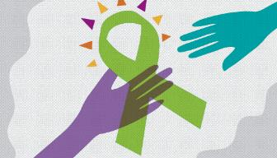

Lime green is the national color of mental health awareness. Wearing a lime green ribbon is a great way to start a dialogue with friends, family, classmates, and co-workers about mental health. Not sure how to start a conversation? Here’s one way:

I wear my lime green ribbon because I support mental health awareness and I believe Each Mind Matters.
Other ways to show your lime green spirit can include sharing a video on social media with a caption. For example:

Did you know that lime green is the national color of mental health awareness? Check out how one lime green ribbon can help many by sharing this 60-second film “The Ribbon of Change” developed by high school students. https://vimeo.com/258015861

Another great idea is to download and print this poster to show your support.

Make sure to visit the Each Mind Matters store where you can purchase your own lime green gear! And don’t forget to check out our events page to see what’s happening in your area.

Remember to visit the (INSERT ORGANIZATION NAME) Facebook (INSERT HYPERLINK), Instagram (INSERT HYPERLINK), or Twitter (INSERT HYPERLINK) to learn about activities, ideas, and tips to promote mental health in your home and community.

[Insert Agency/CBO Signature Line]

